Guided Beach Mediation and Expressive art
Materials Needed: Access to YouTube, or a print out of script that someone can read to the participant. A relaxing location, and Art materials and white paper for afterward. Art materials can include crayons, markers, colored pencils, (when using paint such as water color make sure to use sturdy mix media or water color paper). Light your favorite candles or use essential oils. Make you space as Zen as possible, you may want to dim the lights for the meditation portion.

Audio Link- https://youtu.be/Lg3eosb9Vy0

Start reading the beach visualization relaxation script:

Get comfortable. Sit in a supportive chair or lie on your back.
Relax your body by releasing any areas of tension. Allow your arms to go limp... then your legs....
Feel your arms and legs becoming loose and relaxed...
Now relax your neck and back by relaxing your spine.... release the hold of your muscles all the way from your head, down your neck....along each vertebra to the tip of your spine...
Breathe deeply into your diaphragm, drawing air fully into your lungs.... and release the air with a whooshing sound....
Breathe in again, slowly.... pause for a moment.... and breathe out slowly through the mouth.....
Draw a deep breath in slowly....Pause…. and out....
In.....pause….and out.....

Become more and more relaxed with each breath....
Feel your body giving up all the tension.... becoming relaxed.... and calm.... peaceful....
Feel a wave of relaxation flow from the soles of your feet, to your ankles, lower legs, hips, pelvic area, abdomen, chest, back, hands, lower arms, elbows, upper arms, shoulders, neck, back of your head, face, and the top of your head....
Allow your entire body to rest heavily on the surface where you sit or lie. Now that your body is fully relaxed, allow the visualization relaxation to begin.
Imagine you are walking toward the ocean.... walking through a beautiful, tropical forest....
You can hear the waves up ahead.... you can smell the ocean spray.... the air is moist and warm.... feel a pleasant, cool sweet breeze blowing through the trees....
You walk along a path....coming closer to the sea....as you come to the edge of the trees, you see the brilliant aqua color of the ocean ahead....
You walk out of the forest and onto a long stretch of white sand.... the sand is very soft powder.... imagine taking off your shoes, and walking through the hot, white sand toward the water....
The beach is wide and long....

Hear the waves crashing to the shore....

Smell the clean salt water and beach....
You gaze again toward the water.... it is a bright blue-green....
See the waves washing up onto the sand..... and receding back toward the ocean.... washing up.... and flowing back down..... enjoy the ever-repeating rhythm of the waves...
Imagine yourself walking toward the water.... over the fine, hot sand.... you are feeling very hot....
As you approach the water, you can feel the mist from the ocean on your skin. You walk closer to the waves, and feel the sand becoming wet and firm....
A wave washes over the sand toward you.... and touches your toes before receding...
As you step forward, more waves wash over your feet... feel the cool water provide relief from the heat....

Walk further into the clear, clean water.... you can see the white sand under the water.... the water is a pleasant, relaxing temperature.... providing relief from the hot sun... cool but not cold....

You walk further into the water if you wish.... swim if you want to.... enjoy the ocean for a few minutes..... allow the visualization relaxation to deepen.... more and more relaxed... enjoy the ocean....

Now you are feeling calm and refreshed...

You walk back out of the water and onto the beach...

Stroll along the beach at the water's edge.... free of worries... no stress... calm..... enjoying this moment....Up ahead is a comfortable lounge chair and towel, just for you...

Sit or lie down in the chair, or spread the towel on the sand.... relax on the chair or towel.... enjoying the sun.... the breeze.... the waves.....You feel peaceful and relaxed.... allow all your stresses to melt away....

When you are ready to return from this moment, do so slowly....
Bring yourself back to your usual level of alertness and awareness....
Keep with you the feeling of calm and relaxation.... feeling ready to return to your day....

Open your eyes, stretch your muscles... and become fully alert... refreshed... and filled with energy.
You can practice this visualization relaxation as often as you wish, to provide a mental vacation whenever you need it. Visualization relaxation is a skill that can be learned; the more you practice, the more skilled you will become and more effectively you will be able to relax using visualization relaxation.

Expressive art Instructions
Now that you are feeling refreshed and relaxed, think about where your mind took you. What colors did you? Images? Sounds? Smells? How did the sand feel? Where you transported to a warm memory?
Now take those feelings from your mediation and I just want you to draw & color what you feel, or what you imagined. There is no right or wrong way, and the image can be everything from a beach scene to an abstraction of color, maybe a sun set? Some ocean foam? Or whatever you would like. There is no judgment, just a simple expression of self.

Below are some images to show you how an interpretation of beach varies from person to person. I find that abstract is the best way to freely express without self- judgment.
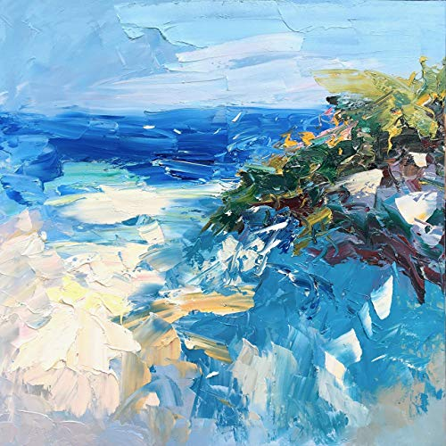 Abstract

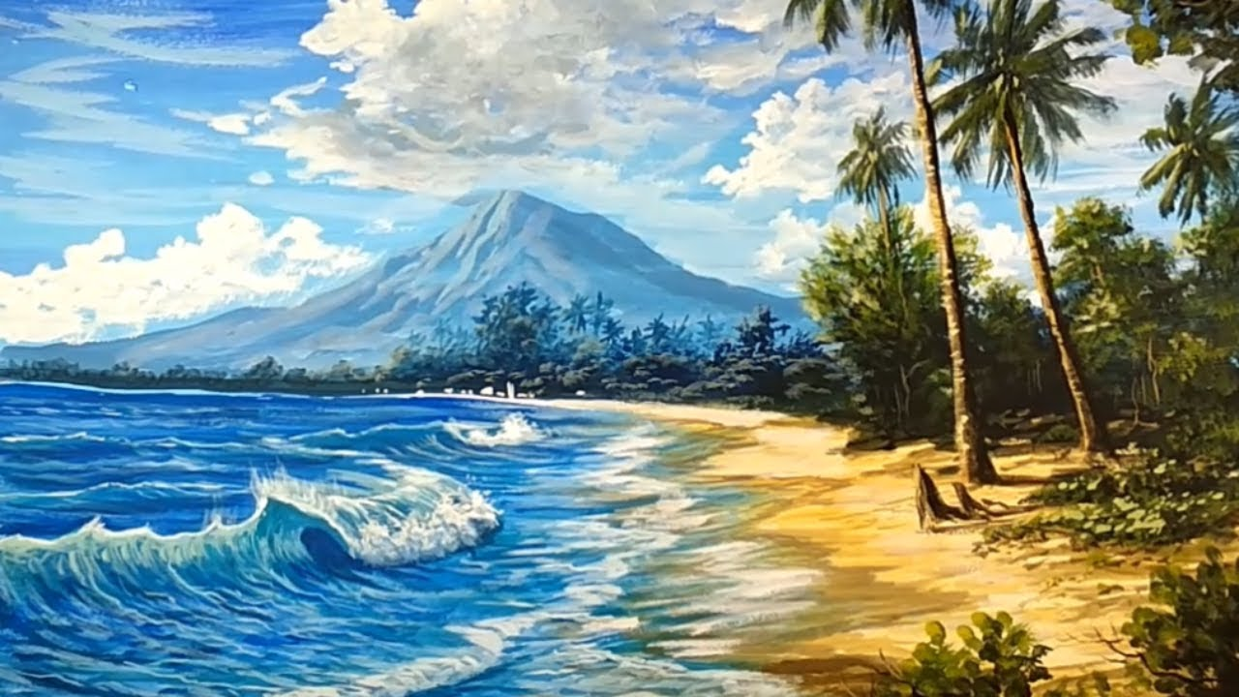
Realism
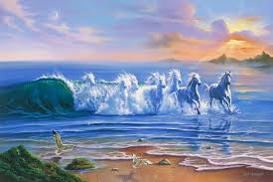
Surrealism

